NT4 Pauline 2: 1 & 2 Corinthians, Galatians, Ephesians, Philippians, Colossians
Dr. Marvin J. Effa
1 Corinthians
Author: Paul, 1 Corinthians 1:1, writing from Ephesus, 1 Corinthians 16:8.
Date of writing: Dates range from 53-57 A.D.
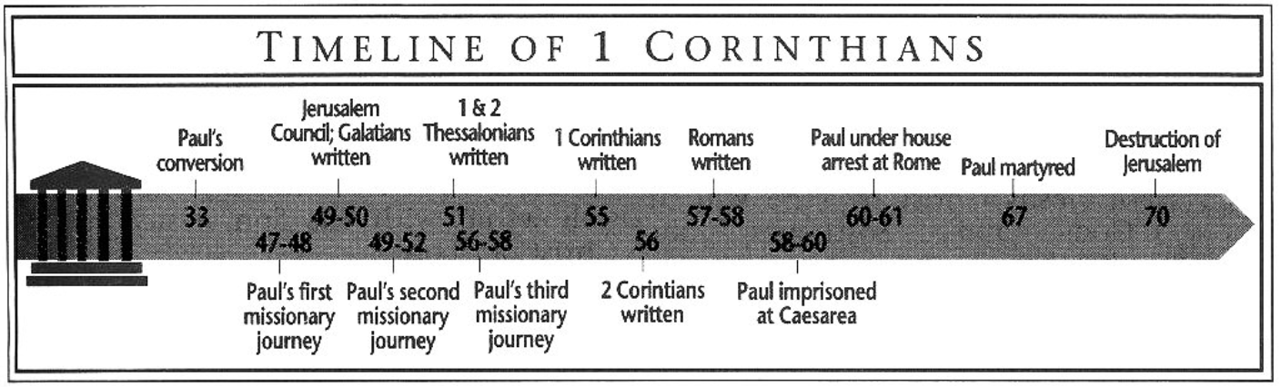 Purpose: to correct divisions, moral, and ethical problems in the church, and to answer questions previously provided to Paul.
Idea: Problems in people and the church can be corrected by apostolic revelation.
Development:
First Corinthians: Paul’s directions to a church full of divisions, immorality, carnality, and doctrinal error.
- Carnal divisions are the work of the carnal believer and not the Spirit, 1-4.
- Open immorality must be dealt with, 5.
- Lawsuits and immorality do not glorify God, 6.
- Paul answers questions about: marriage (7), pagan temples (8-10), masculinity/femininity (11), Communion (11), spiritual gifts in the worship service (12-14), 7-14.
- Not every believer will die, but all will be resurrected similar to Christ’s resurrection, 15.
- The church should send money to Jerusalem, 16.
Key Passage Exegesis
- The church must deal with serious, public sins when repentance is absent, 1 Corinthians 5.
- Paul addresses marriage and celibacy, 1 Corinthians 7.
- There are limits on a believer’s liberty, 1 Corinthians 8-10.
- A central passage on the resurrection, 1 Corinthians 15.
2 Corinthians
Author: Paul, 2 Corinthians 1:1.
Date of writing: Dates vary, but written shortly after 1 Corinthians.
Purpose: to re-establish his authority in the church after the “sorrowful letter.”
Idea: Church-wide repentance and obedience to Paul’s instructions will result in eternal reward and the avoidance of discipline.
Development:
- Paul’s Holy Spirit empowered ministry of the New Covenant is independent of the Corinthians’ criticisms of their apostle, 1-3.
- Although constantly persecuted and beaten down (4), Christ’s love compels them to be ambassadors, knowing that their eternal dwelling and the judgment seat of Christ make the present difficulty lighter (5-6a). They are to accept God’s love through Paul and share in the sufferings of the Gospel (6b-7), 4-7.
- They should send money to Jerusalem, 8-9.
- Paul’s authority is well established; repent or he will discipline them, 10-13.
Key Passage Exegesis
- God has given each believer a ministry of reconciliation, 2 Corinthians 3.
- When believers die, they are not disembodied spirits, 2 Corinthians 5.
- The central passage on New Testament giving, 2 Corinthians 8-9.

Galatians
Author: Paul, Galatians 1:1
Date of writing: The date is uncertain, but most conservative scholars take an early date.
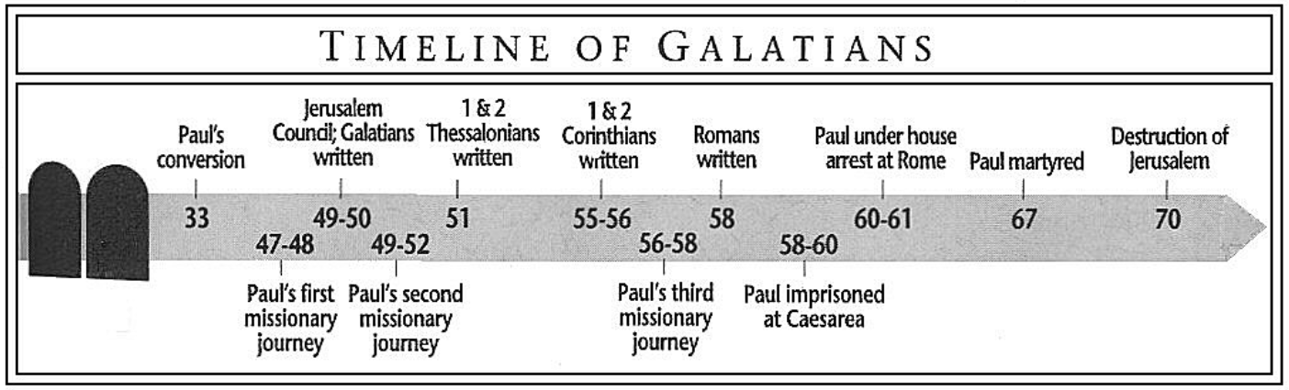
Purpose: The recipients had moved from the Gospel to a works-based system whereby faith was regarded as inadequate for one’s state and standing before God.
Idea: Accept the suffering that goes with a grace-based system.
Development: The book is a logical development and defense of the Gospel against the Mosaic Law vs. grace and works vs. faith. Each section follows logically upon the preceding.
Introduction (Gal. 1:1-5)
- The Apostle Paul’s gospel will deliver us, 1:1-5.
Never, Never add any works to the Gospel (Gal. 1:6-4:31)
- If we leave the gospel, we turn away from God, 1:6-9
- Pleasing God (who gave him the Gospel) is Paul’s only concern, 1:10-2:14.
  - One cannot please God and men, 1:10.
  - While in Arabia, Jesus revealed the gospel to Paul, 1:11-17.
  - The key apostles and leaders agreed with Paul’s gospel, 1:18-2:10.
  - Peter sinned by returning to the law, 2:11-14.
- Christ instructed the Apostles to leave the law, 2:15-21.
  - No one can be justified by works, only by faith, 2:15-16.
  - A return to law is sin, 2:17-19.
  - The Christian life is lived by faith not by works, 2:20-21.
- Abraham was justified by faith not by works, 3:1-15.
  - Our experience validates faith, not works, 3:1-5.
  - Abraham was justified by faith, 3:6-9.
  - Christ redeemed us from the curse of the law, 3:10-14
    - Law brings curses, 3:10-12.
    - Christ was cursed so we could be blessed, 3:13-14.
- The law cannot annul the promise, 3:15-29.
  - Our inheritance comes from promise, 3:15-18.
  - The law was to bring us to Christ, 3:19-25.
  - Faith identifies us with Christ and makes us heirs, 3:26-29.
- Heirs should not be slaves to the law, 4:1-31.
  - The Son redeemed us from the law so we would be sons, 4:1-7.
  - It is wrong to return to the law, 4:8-11.
  - Follow Paul, not the slave-making false teachers, 4:12-20.
  - Even the law teaches us not to return to the law! 4:21-31.
Only the Spirit of Grace can produce love (Gal. 5:1-6:10)
- Stand in the liberty of Grace, 5:1-12.
  - Christ will not help you if you turn to law, 5:1-3
  - Only faith, not law, produces love, 5:4-6.
  - The works-based teachers are NOT from God, 5:7-12.
- Allow liberty to produce love, 5:13-6:10.
  - Stop fighting and love one another, 5:13-15.
  - Walk by the Spirit, not the flesh, 5:16-26.
  - Restore others in humility, 6:1-5.
  - By the Spirit, share and do good to all, 6:6-10.
Conclusion (Gal. 6:11-18)
- Accept the suffering that goes with a grace-based system! 6:11-18.
Key Passage Exegesis
- All the Apostles were agreed on the Gospel, Galatians 1:18-2:14.

Ephesians
Author: Paul, Ephesians 1:1
Date of writing: 61 A.D. Written from Rome during his imprisonment listed in Acts 28.
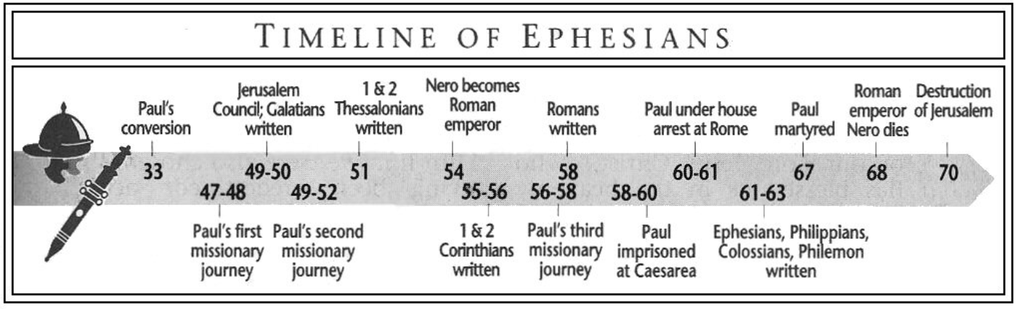
Purpose: to establish the equality of the Jew and Gentile in the body of Christ.
Idea: Since believing Gentiles are on equal footing with believing Jews they should walk worthily.
Development: Inheritance among the Saints
- God’s amazing grace has brought Gentile believers into an eternal inheritance, Eph. 1:1-3:21.
  - The Apostle Paul writes to saints and believers, 1:1-2.
  - God wished, planned, and determined from the beginning that Gentiles should know His grace through Christ and receive an inheritance, 1:3-14.
  - Paul prays that the Gentiles will understand the inheritance and the incredible power of the Messiah who is the head of the church, 1:15-23.
  - Our serious sin was no match for God’s grace which will be demonstrated forever, 2:1-10.
  - The war between Jew and Gentile is over; Gentiles are now fellow-citizens, 2:11-22.
  - Paul, the Gentile’s apostle, declared the mystery of the fellow heirship, 3:1-13.
  - Paul prays that we would comprehend God’s awesome grace, 3:14-21.
- God’s grace transforms the person, the household, and the culture, Eph. 4:1-6:20.
  - Our response to God’s grace should be the gracious exercise of our gifts, 4:1-16.
  - Put off the Old Man; put on the New Man, 4:17-32.
  - Inheritance in the kingdom requires living in the light and not the darkness, 5:1-21.
  - Grace transforms the household, 5:22-6:9.
  - Grace enables believers to stand against evil wherever we find it, 6:10-20.
Key Passage Exegesis
- The message of the church is new revelation, Ephesians 3.
- The longest household section Paul provided to the church, Ephesians 5-6.

Philippians
Author: Paul, Philippians 1:1.
Date of writing: 61 A.D. Written from Rome during his imprisonment listed in Acts 28.
Purpose: to thank the Philippian church for financial support and to address certain schisms.
Idea: The jailed apostle was deeply stirred by the church’s love—what a contrast to the Roman churches.
Development:
- While longing for them, Paul has evangelized the jail; take courage from his suffering, 1.
- We should follow Christ’s humility and allow the Gospel to transform us, 2.
- Be on guard against legalists; walk by the Spirit with other believers, 3
- Stop fighting, and strengthen the existing virtues, 4.
Key Passage Exegesis
- Christ’s humility serves as a model for believers, Philippians 2.

Colossians
Author: Paul, Colossians 1:1
Date of writing: 61 A.D. Written from Rome during his imprisonment listed in Acts 28.
Purpose: to warn the church about doctrinal error.
Idea: Godly living doesn’t come from philosophy or asceticism, but from the indwelling Christ.
Development:
- God’s grace qualifies us for an inheritance in the coming Kingdom, Colossians 1:1-14.
- Christ, who is over everything, reconciled us and gave Paul the revelation of the church, Colossians 1:15-29.
- Do not allow philosophy or asceticism to cheat you, Colossians 2:1-23.
- Put on the New Man and fulfill your household duties, 3:1-4:18.
Key Passage Exegesis
  - Christ is superior to all Jewish and secular philosophies, Colossians 1-2.

